Class Enrollment Management System
- 700759484 - Phanindhar Reddy Mamidi
- 700756326 - Umesh Reddy Gaddam
- 700762484 - Akshaya Reddy Gopidi
- 700773957 - Madhan Reddy Singireddy Patak
Class Enrollment Management System Documentation

Purpose of the Database
- The Class Enrollment Management System facilitates structured course registration while ensuring that students enroll in sections based on seat availability, semester schedules, and institutional policies.
- The system provides a structured way to manage course offerings, section assignments, and student enrollment while preventing scheduling conflicts and optimizing classroom utilization.
- Each section of a course has a fixed number of seats, determined by classroom capacity, ensuring enrollments do not exceed available space.
- Students can register for courses within an open enrollment period at the beginning of each semester, selecting from available sections that align with their academic plans.
- The enrollment process follows a first-come, first-served basis. If a section reaches capacity, students may be placed on a waitlist.
- The system manages key entities, including students, instructors, courses, sections, semesters, and classroom capacities.

Users and Their Information Needs

1. Admins
- Oversee course availability and ensure sections align with classroom capacities.
- Manage registration windows, enrollment policies, and course structure.
- Monitor student enrollment records and academic compliance.

2. Instructors
- Set up their teaching schedules before student enrollment begins to prevent scheduling conflicts.
- Once assigned to a course section, their schedule remains fixed, ensuring structured course delivery.
- Manage students enrolled in their sections and oversee grading policies.

3. Students
- Register for courses during the enrollment period, selecting sections that align with their academic plans.
- Ensure that selected sections do not overlap in their schedules, as the system prevents double bookings.
- Modify enrollments before the add/drop deadline, adhering to institutional policies.
- View their academic history, enrolled courses, and semester schedules.

Problems the System Solves
- Seat Availability Management: Prevents over-enrollment and dynamically updates available seats.
- Schedule Conflict Prevention: Ensures students cannot enroll in overlapping sections.
- Efficient Registration System: Automates course enrollment based on institutional policies.
- Waitlist Management: Places students on a waitlist if sections are full and updates enrollments when seats become available.
- Enrollment Compliance: Ensures students do not exceed the allowed number of courses per semester.
- Drop and Refund Policy Enforcement: Manages course drop requests and applies refund policies based on the institution’s regulations.

Entities and Attributes

Admins
- admin_id
- name
- email
- password
- role
- created_at

Instructors
- instructor_id
- name
- email
- password
- department
- phone_number
- created_at

Students
- student_id
- name
- email
- password
- dob
- phone_number
- enrolled_courses
- created_at

Courses
- course_id
- course_name
- course_code
- description
- credit_hours
- created_at

Semesters
- semester_id
- semester_name
- start_date
- end_date
- enrollment_open_date
- enrollment_close_date
- created_at

Sections
- section_id
- course_id (FK)
- instructor_id (FK)
- semester_id (FK)
- schedule
- seat_capacity
- available_seats
- created_at

Enrollments
- enrollment_id
- student_id (FK)
- section_id (FK)
- status
- created_at

Input Data to the Database
- Admin Data: User credentials, role management, system-wide permissions.
- Instructor Data: Personal details, course assignments, schedules.
- Student Data: Personal details, enrolled courses, registration status.
- Course Data: Course catalog information, credit hours, and descriptions.
- Section Data: Instructor assignments, schedules, seat capacity.
- Semester Data: Start/end dates, enrollment windows.
- Enrollment Data: Student registration records, status updates.

Information to Be Stored in the Database
- Admin Information: System-wide permissions, user roles, and operational controls.
- Instructor Information: Teaching assignments, course sections, and schedules.
- Student Information: Enrollment history, personal details, and academic records.
- Course Information: Course catalog, section offerings, and credit hour allocations.
- Semester Information: Structured course offerings per academic term.
- Enrollment Information: Student registrations, drop records, and waitlist management.
Schema
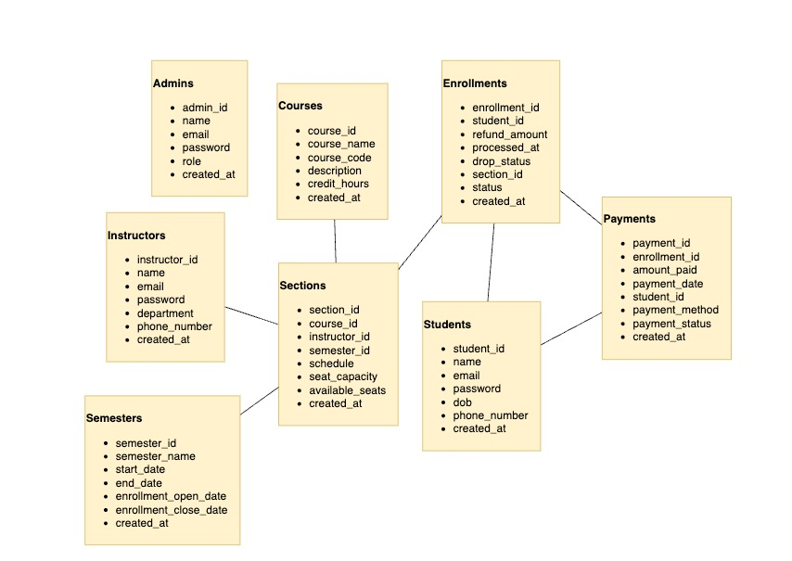

Screenshots
Admins
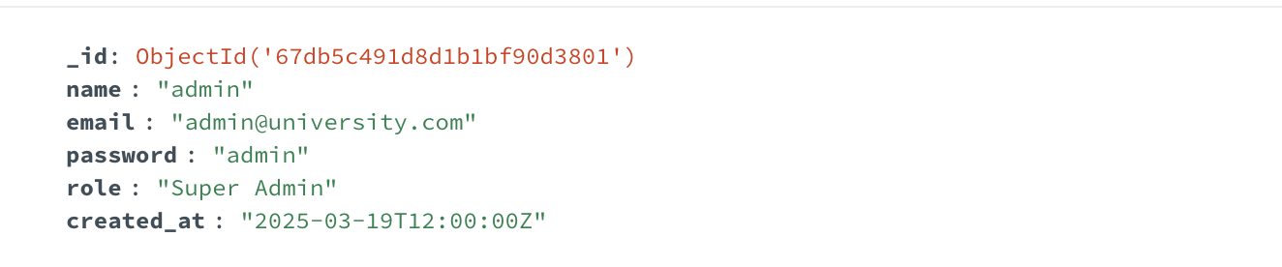
Instructors
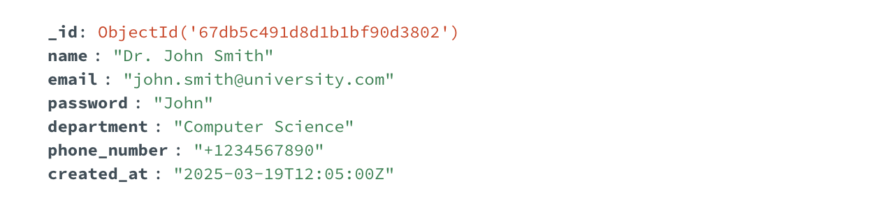
Students
